**SRM INSTITUTE OF SCIENCE AND TECHNOLOGY**

**Department of Electronics and Communication Engineering**

**Laboratory Report Cover Sheet**

**18ECC303J – COMPUTER COMMUNICATION NETWORKS**

### **EVEN SEM 2022-23**

Name :

Section :

Venue :

Experiment title : Simulation of token ring protocol and to study the performance.

|  |  |  |
| --- | --- | --- |
| **PARTICULARS** | **MAX MARKS** | **MARKS OBTAINED** |
| Pre lab & Post lab | 10 |  |
| Lab performance | 15 |  |
| Record | 05 |  |
| Viva | 10 |  |
| Total | **40** |  |

**Report Verification**

Staff Name:

Signature with date:

### **3. Simulation of token ring protocol and to study the performance.**

###### **3.1Introduction:**

The purpose of this experiment is to understand the concept of demand assignment versus random access, setting priorities and token management in a ring LAN. In this lab you will be able to implement a token –passing access method for a ring LAN.

###### **Hardware Requirement**

* + - 3PCs with NIU card
    - Network Emulation Unit
    - Jumper Cables

###### **Background**

Token ring local area network (LAN) technology is a local area network protocol which resides at the data link layer (DLL) of the OSI model. It uses a special three-byte frame called a token that travels around the ring. Token ring frames travel completely around the loop. Stations on a token ring LAN are logically organized in a ring topology with data being transmitted sequentially from one ring station to the next with a control token circulating around the ring controlling access. Physically, a token ring network is wired as a star, with 'hubs' and arms out to each station and the loop going out-and-back through each.

Each station passes or *repeats* the special token frame around the ring to its nearest downstream neighbor. This token-passing process is used to arbitrate access to the shared ring media. Stations that have data frames to transmit must first acquire the token before they can transmit them. Token ring LANs normally use differential Manchester encoding of bits on the LAN media.

When no station is transmitting a data frame, a special token frame circles the loop. This special token frame is repeated from station to station until arriving at a station that needs to transmit data. When a station needs to transmit data, it converts the token frame into a data frame for transmission. Once the sending station receives its own data frame, it converts the frame back into a token

###### **Pre Lab Questions**

1. What is meant by token and how is it used in ring methodology?
2. Give the advantages of token ring over Ethernet.
3. Define Token Holding Timer (THT).
4. Give the IEEE standard of token ring LAN.

###### **Procedure**

**3.5.2 Token Ring**

1. Click on the Token ring icon  twice from the desktop.
2. Click the Configuration button  in the window in both the PC’s.

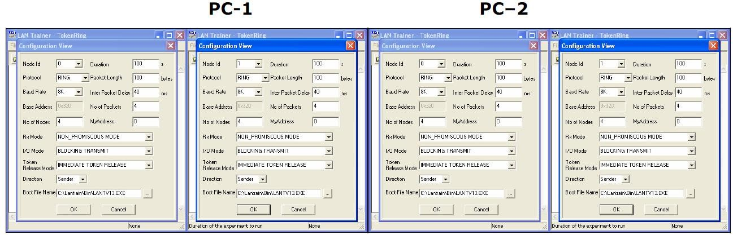

Setting the configuration menu:

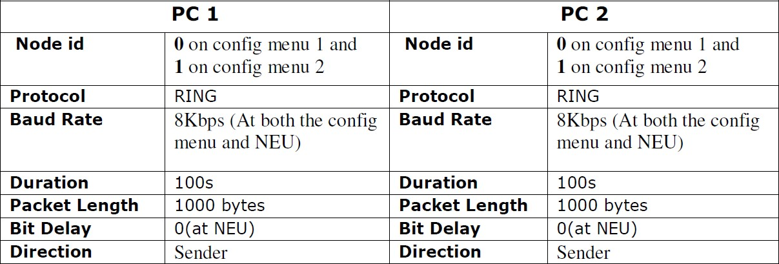

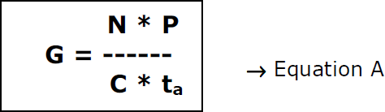

G is the generated load in the network.

N is the number of nodes participating in the network. For example, let us say that 4 nodes (using 2 computers)

P is the packet length expressed in bits; say 100 bytes (800 bits).

C is the data rate normally set as 8kbs, which is selected in the NEU.

ta is the inter packet delay expressed in seconds; the time interval between two consecutive packets generated.

So, lets assume ta= 40 milliseconds and substitute the above mentioned parameters in the Equation A which leads to G = 10. Like wise assume various values of ta to generate offer loads in the range of 0.1 to 10. Substitute the value of ta in the configuration menu.

1. Click OK button and Download the driver to the NIU using the BOOT button command.

Booting from any one of the applications is enough.

1. Run the experiment by clicking button or by choosing RUN _ Start from each application.

Run the all the experiments at the same time.

1. Set the Token Holding Time (THT) (say 10000 ms).
2. View the statistics window for results. To view the statistics window click on button

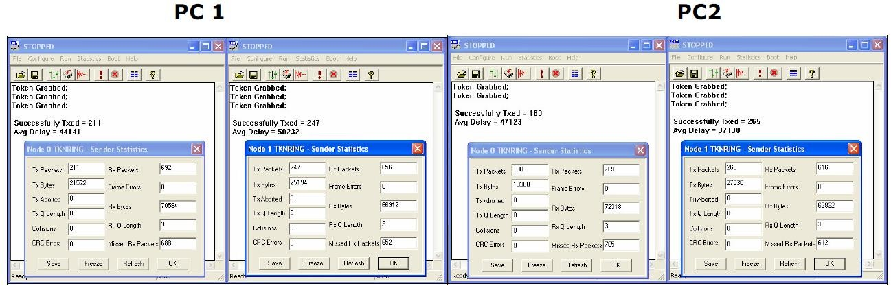

1. Note down the readings once the experiment is completed.
2. Repeat the above steps for various values of ta.
3. Calculate the Practical offered load from the below given formula and plot the graph between the practical Offered load and Throughput.

Note: You can also use the template for plotting the graph.

1. Repeat the experiments for various values of Packet length, Node, Data rate.
2. Repeat the above steps, while running the experiment set the BER to 10-2 in the NEU or try to stop one of the nodes and observe the behavior and explain the same.

Calculation of Practical Throughput (X) from the obtained readings:

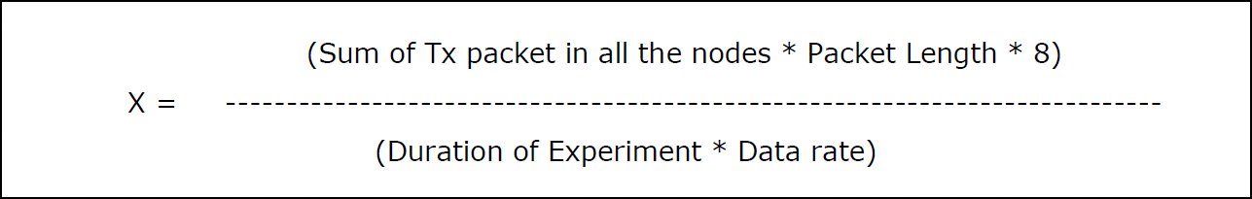

Calculation of the Offered load:

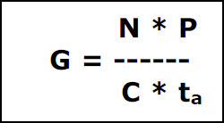

G – Offered load

N – Number of nodes

P – Packet length in bits C – Data rate in bits/sec

ta – Inter packet delay in millisecs.

Model Tabulation:

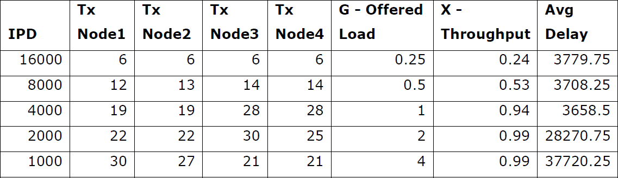

Model Graph

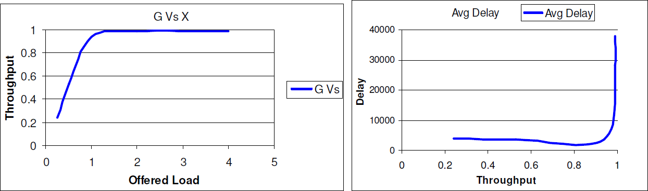

###### **Post lab questions:**

1. Calculate the propagation time and transmission time for 2.5Kbyte message if the bandwidth of 1Gbps? distance is 12,000 Km and light travels at 2.4x108 m/s
2. Give the frame format of Token Ring LAN
3. What type of token passing used in FDDI.
4. Which network architecture uses a dual-ring topology?
5. Compare the performance between ring and bus methodology.

###### **Result:**

Thus, token bus protocol is simulated and its performance is studied